**[docker –version](https://www.edureka.co/blog/docker-commands/" \l "version)**

[**docker pull**](https://www.edureka.co/blog/docker-commands/#pull)

[**docker run**](https://www.edureka.co/blog/docker-commands/#run)

[**docker ps**](https://www.edureka.co/blog/docker-commands/#ps)

[**docker ps -a**](https://www.edureka.co/blog/docker-commands/#psa)

[**docker exec**](https://www.edureka.co/blog/docker-commands/#exec)

[**docker stop**](https://www.edureka.co/blog/docker-commands/#stop)

[**docker kill**](https://www.edureka.co/blog/docker-commands/#kill)

[**docker commit**](https://www.edureka.co/blog/docker-commands/#commit)

[**docker login**](https://www.edureka.co/blog/docker-commands/#login)

[**docker push**](https://www.edureka.co/blog/docker-commands/#push)

[**docker images**](https://www.edureka.co/blog/docker-commands/#images)

[**docker rm**](https://www.edureka.co/blog/docker-commands/#rm)

[**docker rmi**](https://www.edureka.co/blog/docker-commands/#rmi)

[**docker build**](https://www.edureka.co/blog/docker-commands/#build)

1. **docker –version**

This command is used to get the currently installed version of docker

**2. docker pull**

**Usage: docker pull <image name>**

**docker pull ubuntu**

This command is used to pull images from the **docker repository**(hub.docker.com)

**docker run**

**Usage: docker run -it -d <image name>**

This command is used to create a container from an image

docker run -it -d ubuntu

**docker ps**

This command is used to list the running containers

**docker ps -a**

This command is used to show all the running and exited containers

**docker exec**

**Usage: docker exec -it <container id> bash**

This command is used to access the running container

Docker exec -it container id bash

**docker stop**

**Usage: docker stop <container id>**

This command stops a running container

**docker kill**

**Usage: docker kill <container id>**

**docker login**

This command is used to login to the docker hub repository

**docker push**

**Usage: docker push <username/image name>**

This command is used to push an image to the docker hub repository

docker push santhoshv86/ubuntu

**docker images**

This command lists all the locally stored docker images

**docker rm**

**Usage: docker rm <container id>**

This command is used to delete a stopped container

**docker build**

**Usage: docker build <path to docker file>**

This command is used to build an image from a specified docker file

docker build .

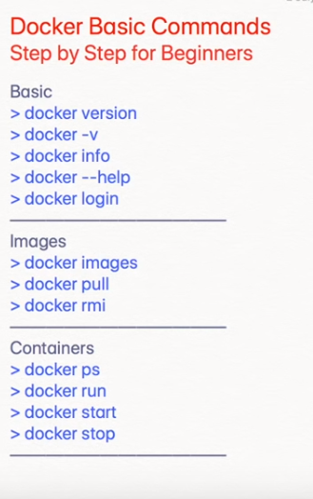

Docker

docker

docker version

docker -v

docker --version

docker info

docker --help

docker images –help

docker run --help

docker login

hub.docker.com

dockerId: santhoshv86

email: santoo.veluri@gmail.com

docker.com99

export PS1=”\u$ ” for shorter version

docker images (list of all images)

docker pull ubuntu

docker images

docker images -q (gives image id)

docker images -q ( gives all the images)

docker rmi –help ( to remove one or more images)

docker images -q

docker rmi (image id)

docker images (now no images)

docker ps –help

docker ps ( to see containers)

docker run ubuntu ( ubuntu is no longer in our system)

docker run -it ubuntu (give sh )

ls

open new window

docker ps

docker start container id

docker stop container id

docker stats

docker run -it ubuntu

docker stats

docker system df (gives disk usage)

docker system prune ( remove unused once)